# HW 5 Report

## Ruijie Song

## March.5.2021

2.1 Exercise: Generating Gaussian random vectors

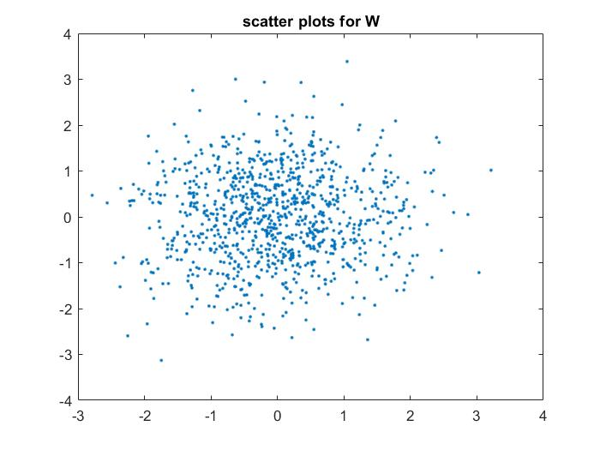

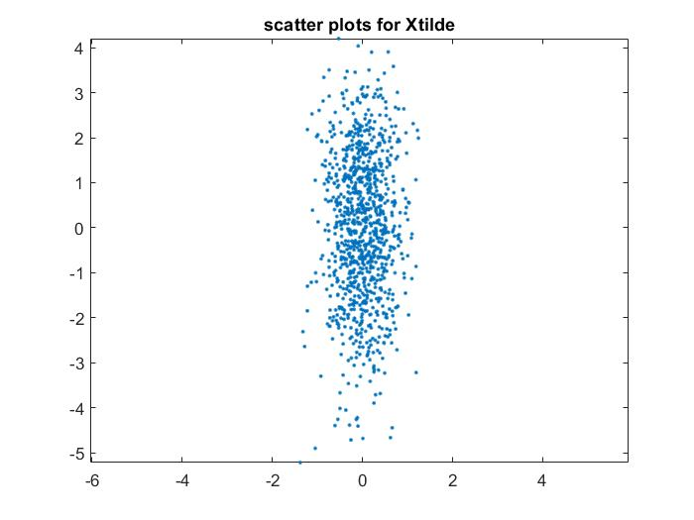

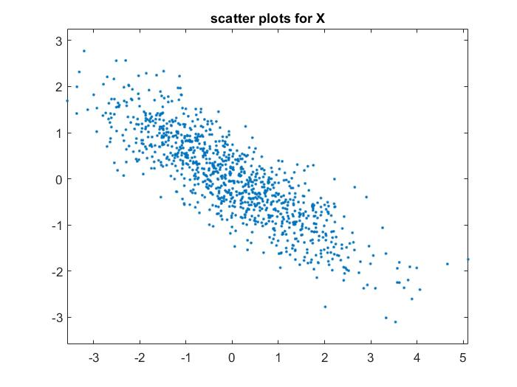

2.2 Exercise: Covariance Estimation and Whitening

1. the theoretical value of the covariance matrix Rx:

|  |  |
| --- | --- |
| 2 | -1.2 |
| -1.2 | 1 |

2. numerical listing of your covariance estimate Rx:

|  |  |
| --- | --- |
| 1.80186189486342 | -1.05439805350776 |
| -1.05439805350776 | 0.903742306202859 |

3.

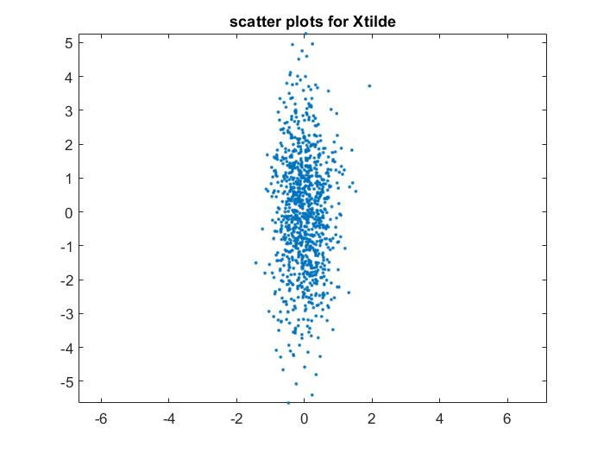

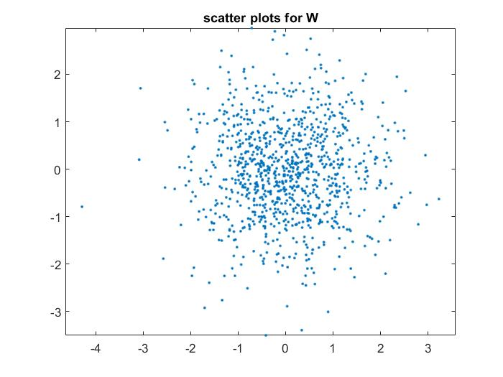

4. numerical listing of the covariance estimate Rw:

|  |  |
| --- | --- |
| 1 | 0 |
| 0 | 1 |

4. Eigenimages, PCA, and Data Reduction

1.

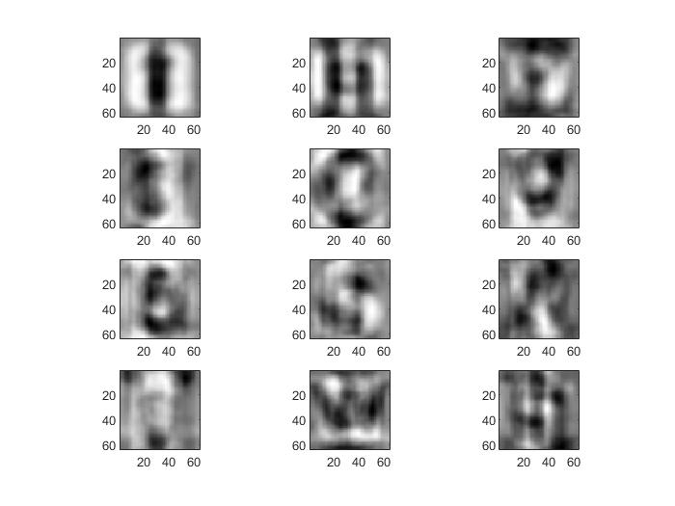

2.

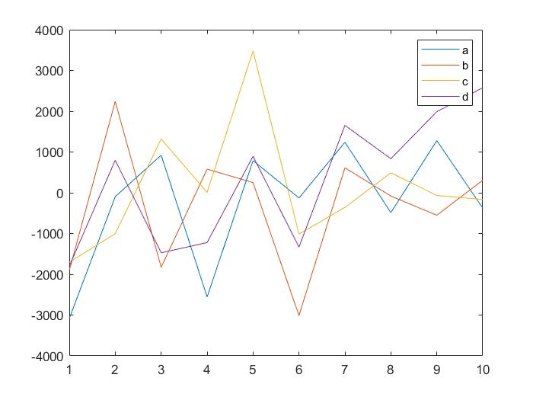

3.

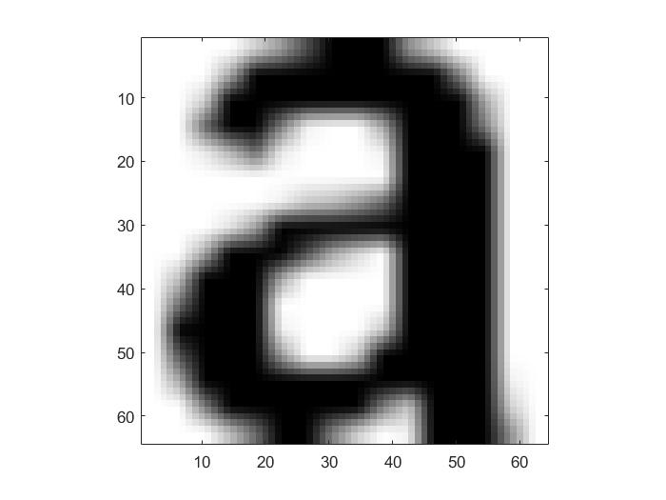

Figure . original image

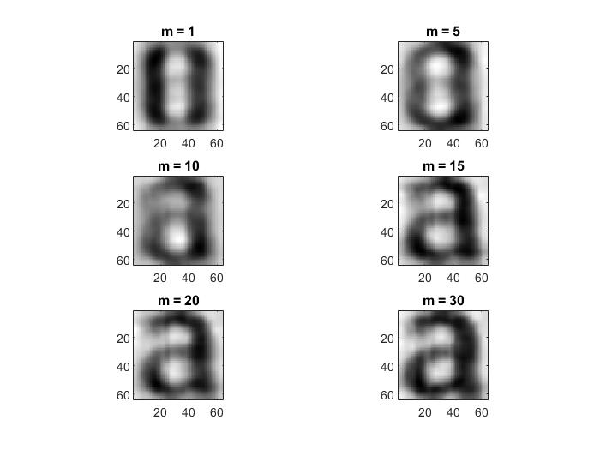

5.1 Exercise: Classification and PCA

|  |  |
| --- | --- |
| Input | Output |
| d | a |
| j | y |
| l | i |
| n | v |
| p | e |
| q | a |
| u | a |
| y | x |

1. Let Bk = Λk, i.e. assume each class has a different diagonal covariance, where the

elements of Λk are the diagonal elements of Rk.

|  |  |
| --- | --- |
| i | l |
| y | v |

2. Let Bk = Rwc, i.e. assume each class has the same covariance, where Rwc is defined as the average within-class covariance

|  |  |
| --- | --- |
| g | q |
| y | v |

3. Let Bk = Λ, i.e. each class has the same diagonal covariance, where the elements of Λ are the diagonal elements of the matrix, Rwc, defined above.

|  |  |
| --- | --- |
| f | t |
| y | v |

4. Let Bk = I, i.e. each class has an identity covariance around a different mean, μk.

|  |  |
| --- | --- |
| q | g |
| f | t |
| y | v |

1. The 2,3 & 4 work the best
2. The accuracy of the estimates is more important. The accuracy of the data model may not impact the estimates. Even the covariance is I, the accuracy of estimates is high.